TUTORIAL ON INSTALLING VIRTUALBOX AND UBUNTU SERVER




Index

1.- Download the virtualbox installation file ---------------- page (1)

2.- Virtualbox is installed ----------------------------- page(4)

3.- Download the Ubuntu Server 22.04 LTS ISO installation file ---------------------------- page (7)

4.- Ubuntu Server 22.04 LTS ISO is installed ----------- page(8)

5.- BIBLIOGRAFIA -------------- Page(19)

1.- Download the virtualbox installation file

Now let's get started by downloading the virtualbox installer, which is the first step in the instruction.
I will, however, first provide a brief description of its purpose and the issue it resolves.
Because Virtualbox may imitate an operating system that differs or is the same as the one the user has on the computer, it is an application that is largely utilized in cybersecurity. This enables the user to do tests without worrying about a virus or attack on their PC.
and because it can mimic the operating system, it also enables you to use servers from a distance.
Thus, it addresses the issues of user safety and the secure operation of an online server.

Click the following link to start the VirtualBox installer download:
However, it's crucial to be aware of the following minimal requirements for VirtualBox to operate before downloading it: https://www.virtualbox.org/wiki/Downloads
a SoC or processor running at 1 GHz or above. RAM memory can be either 1 GB or 2 GB for 32 or 64 bits. Hard drive capacity: 20 GB for 64-bit operating systems, or 16 GB for 32-bit ones. Graphics cards can use the WDDM 1.0 driver or DirectX 9.
Choose the installer for the operating system you have and click on it, and it will start downloading. Figure 1
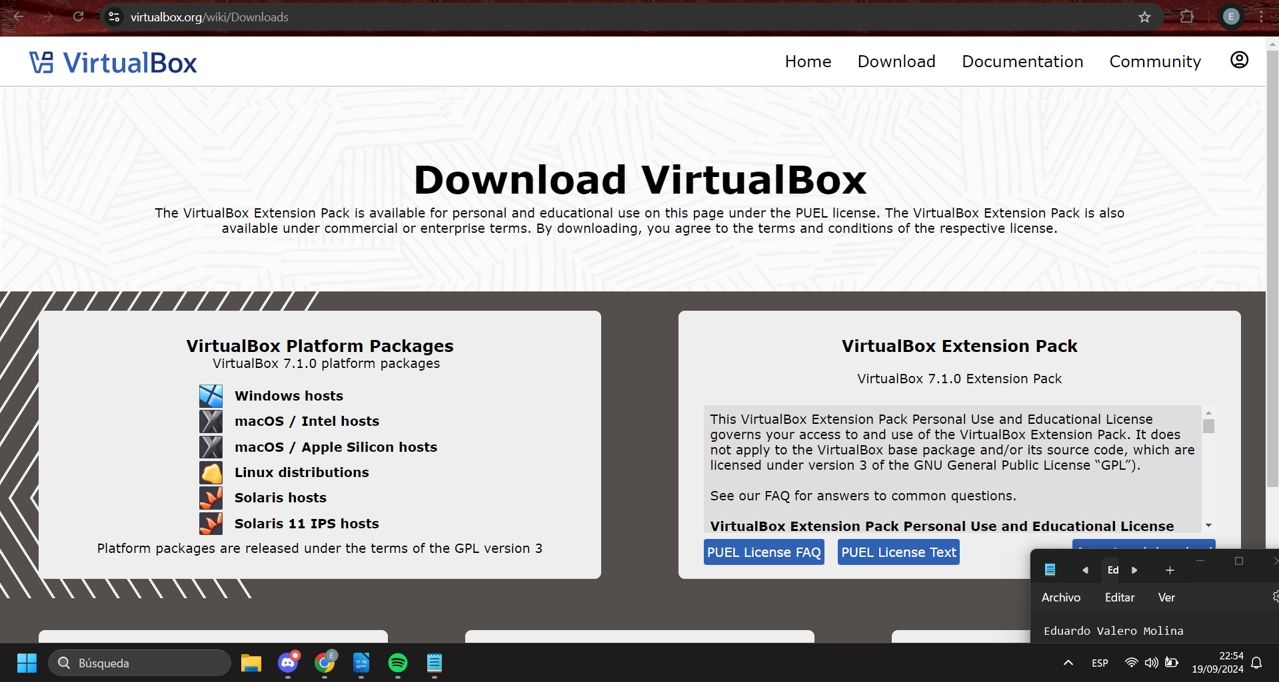Figure 1

2.- Virtualbox is installed

Once downloaded, we will double-click the installer and begin the installation:

Once you double-click the installer, the following screens will appear, and you shouldn't modify any of the options shown, so you just need to click on next.
All you have to do is click on next, yes, and install in the images 1-6.

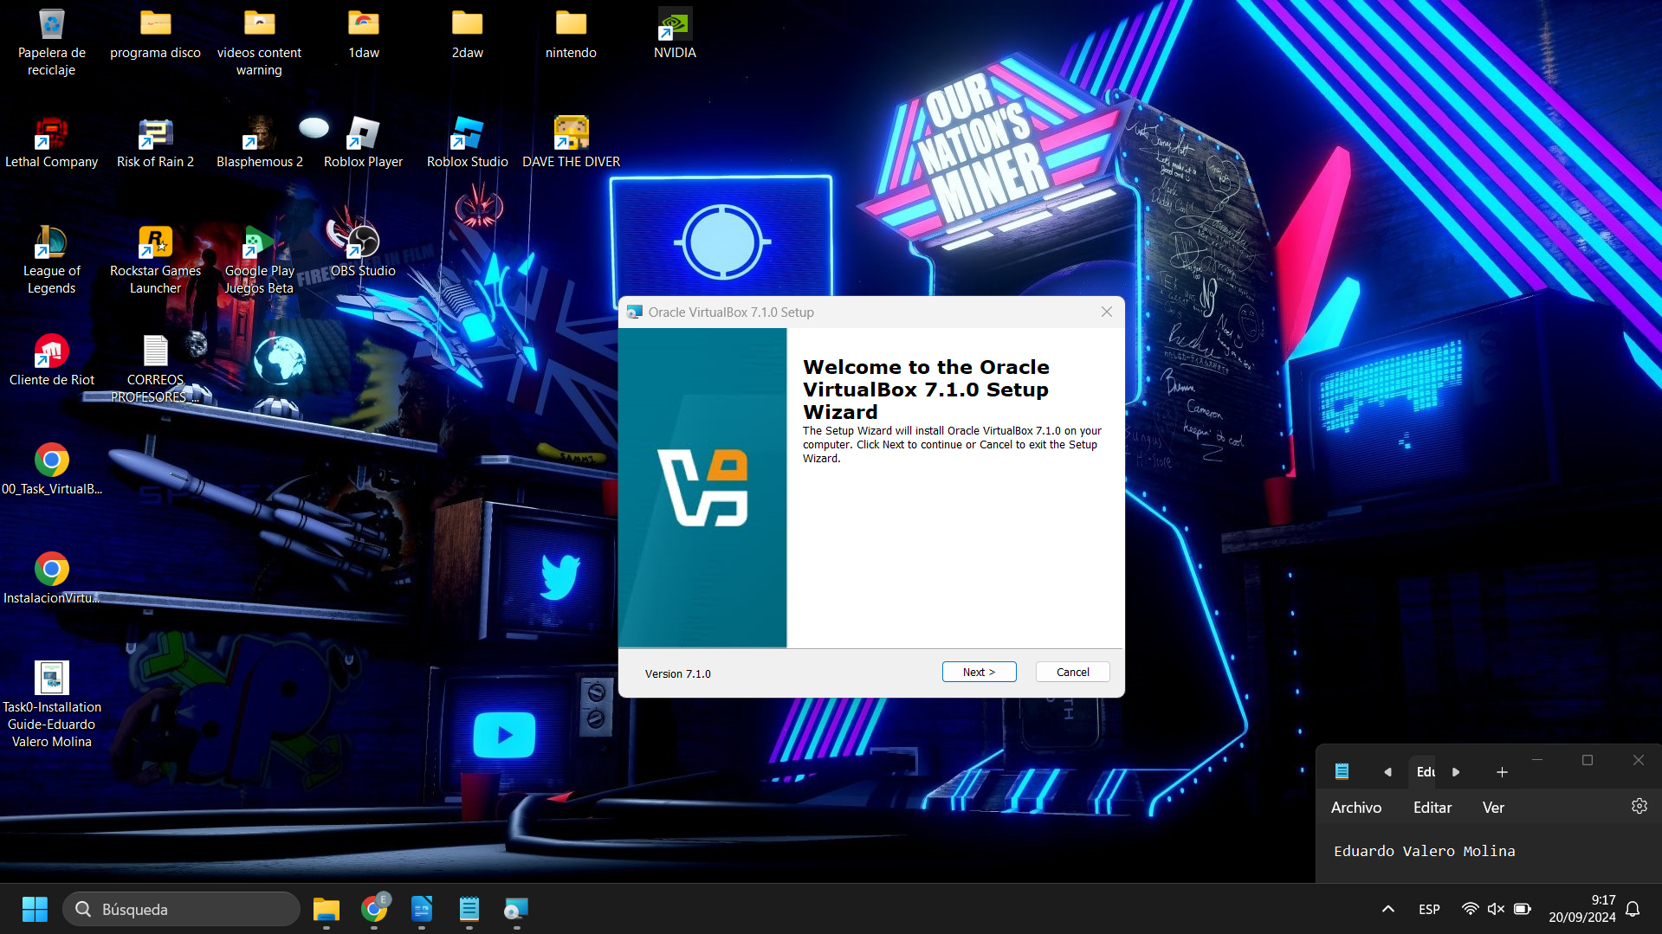
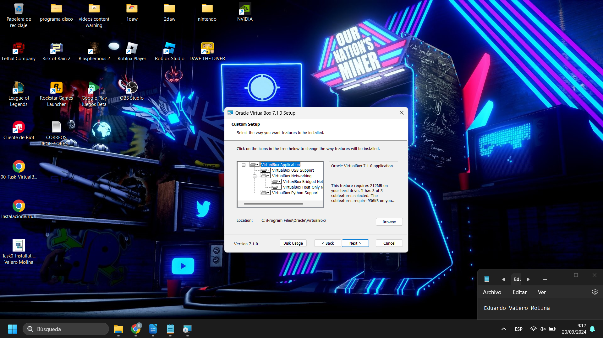
Figure 1 installation

Figure 2 installation
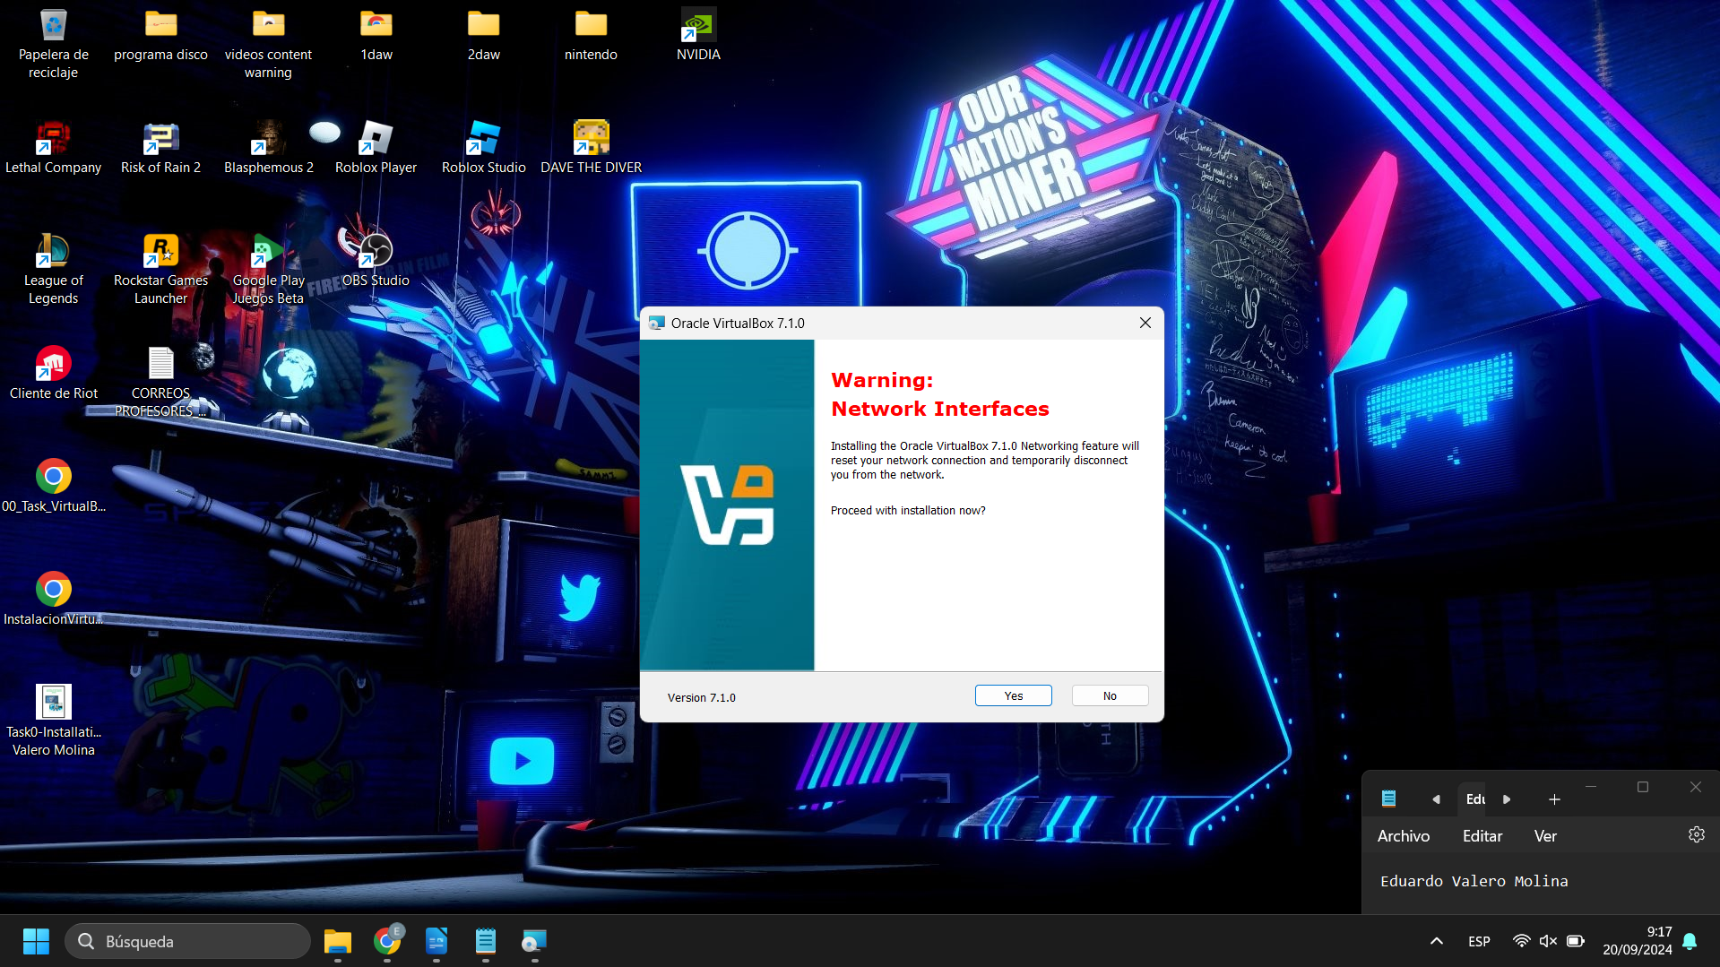In this part, it gives us a warning because if we want the computer to restart when the installation is finished.
Figure 3 installation

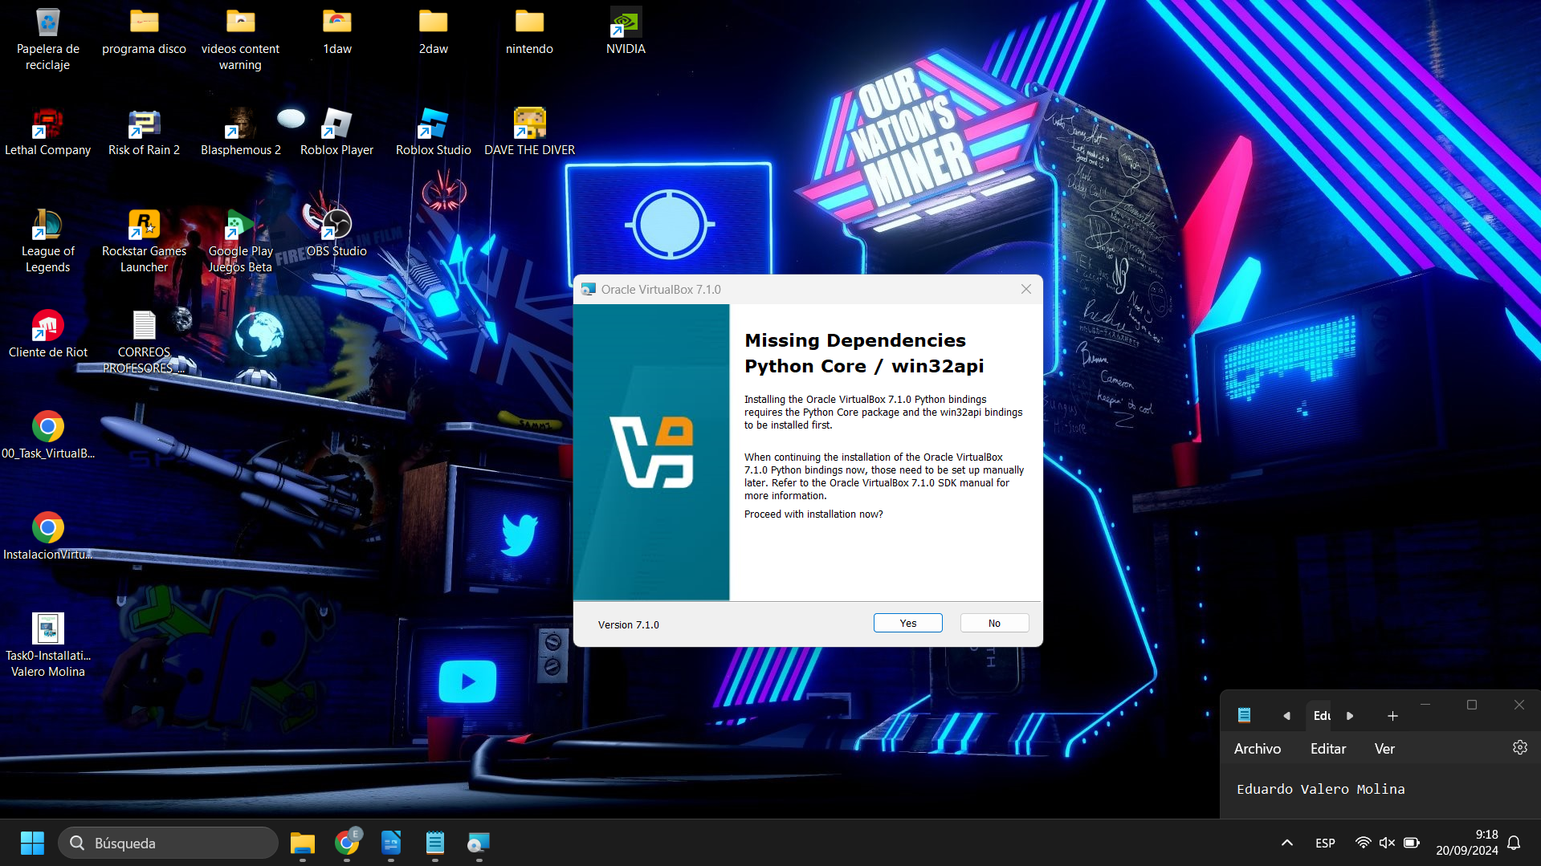In this step, we will see on the screen whether we want to install an API that is usually linked to make the program work better, and we will select yes in this case.
Figure 4 installation
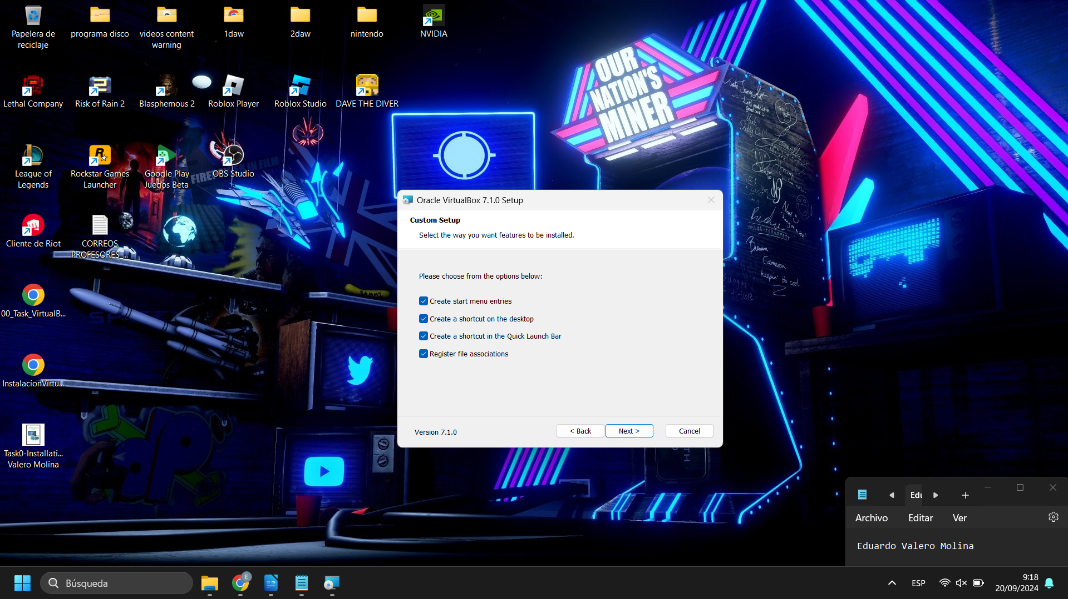In the following image, it will show us that if we want to create a shortcut on the desktop, in the taskbar, and in the start menu, we will check all the boxes and click next.

Figure 5 installation
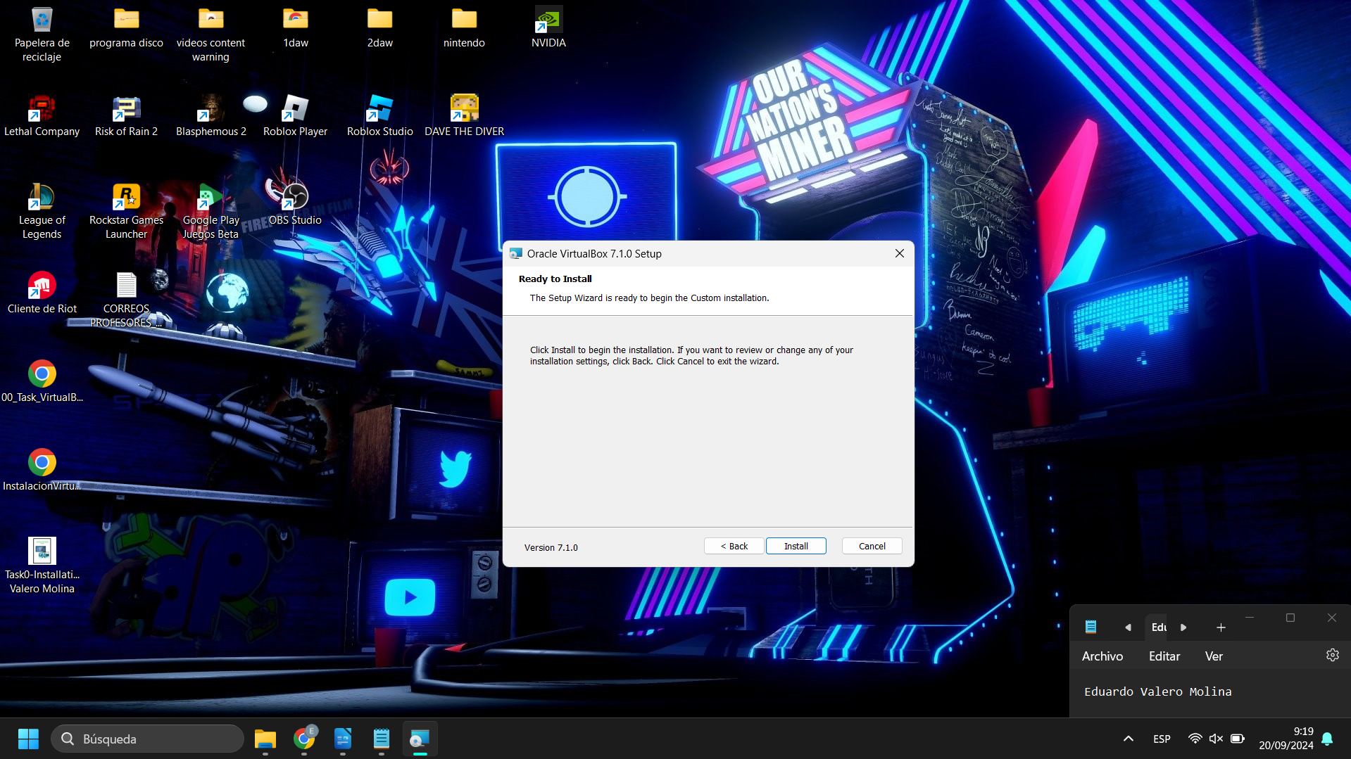And in the last image, we are presented with a question asking if we want to start the installation or if we want to cancel it; we will click on install.

Figure 6 installation
3.- Download the Ubuntu Server 22.04 LTS ISO installation file

We are now going to download Ubuntu Server 22.04, which is a server software. This is the internet link where you may get the ISO file: https://ubuntu.com/download/server
But first, it's important to understand that the following prerequisites must be met for Ubuntu Server to operate: A free disk space of 25 GB. For installation support, a USB port or a DVD player is required. a dual-core CPU running at 2 GHz or above. 4 GB of primary memory (but it can still function with 1 GB).

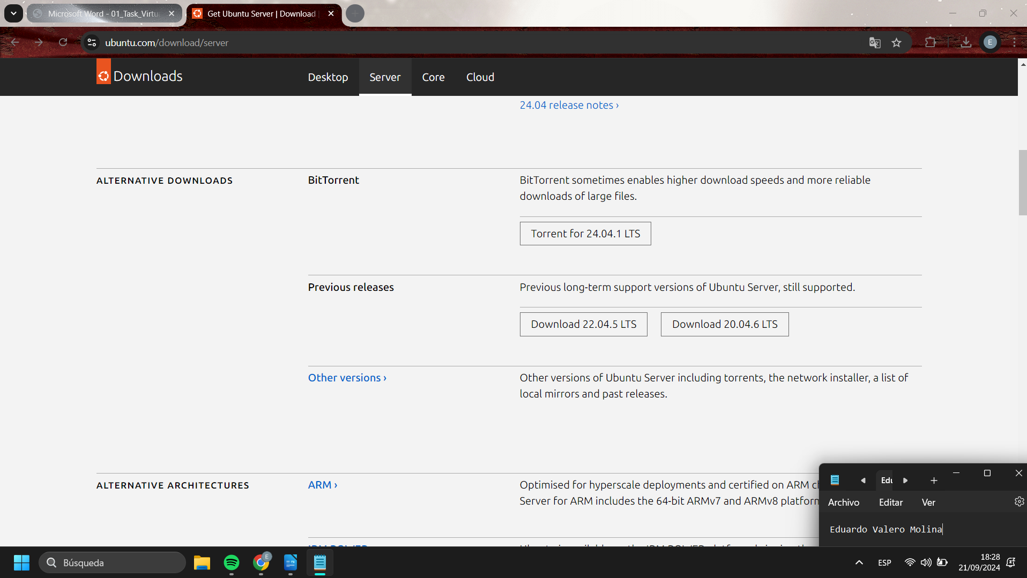
After arriving at the page, we scroll down until we see "download ubuntu server 22.04.5". We then click on it to initiate the download.
FIGURE 1 DOWNLOAD UBUNTU SERVER
4.- Ubuntu Server 22.04 LTS ISO is installed

Next, we will demonstrate how to mount the ISO file into VirtualBox. Following the configuration and installation of Ubuntu Server, we will use the following instructions to install the graphical mode.
This command is used on Linux systems running Debian to update the package index.

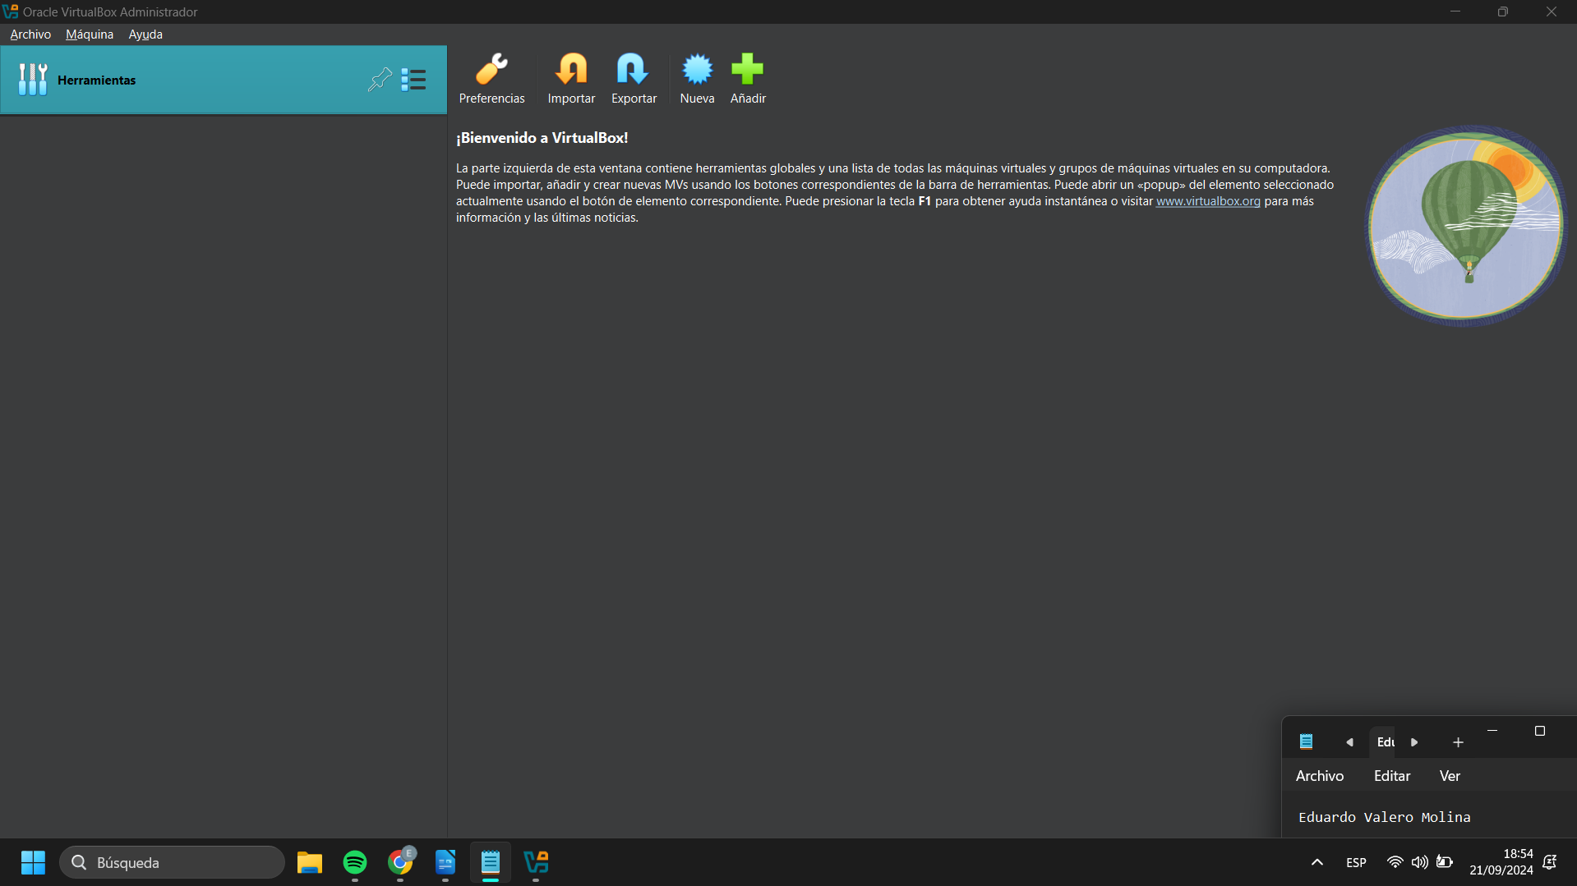
sudo apt-get install ubuntu-desktop
apt-get install --reinstall ubuntu-desktop
reboot
In this image, once you have selected to create, a window will appear where you can enter the name of the virtual machine, the ISO you want to use, and if you don't have an ISO, VirtualBox will replace it for you. In this case, you need to place the Ubuntu Server ISO.
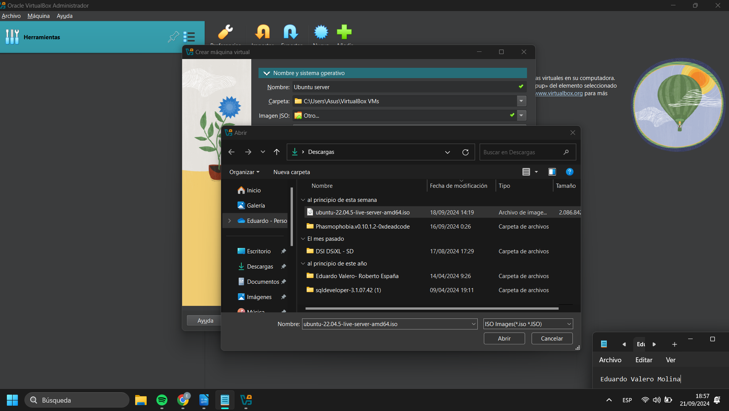Figure1 : create virtual machine
Once created, it appears in the VirtualBox startup to run it.
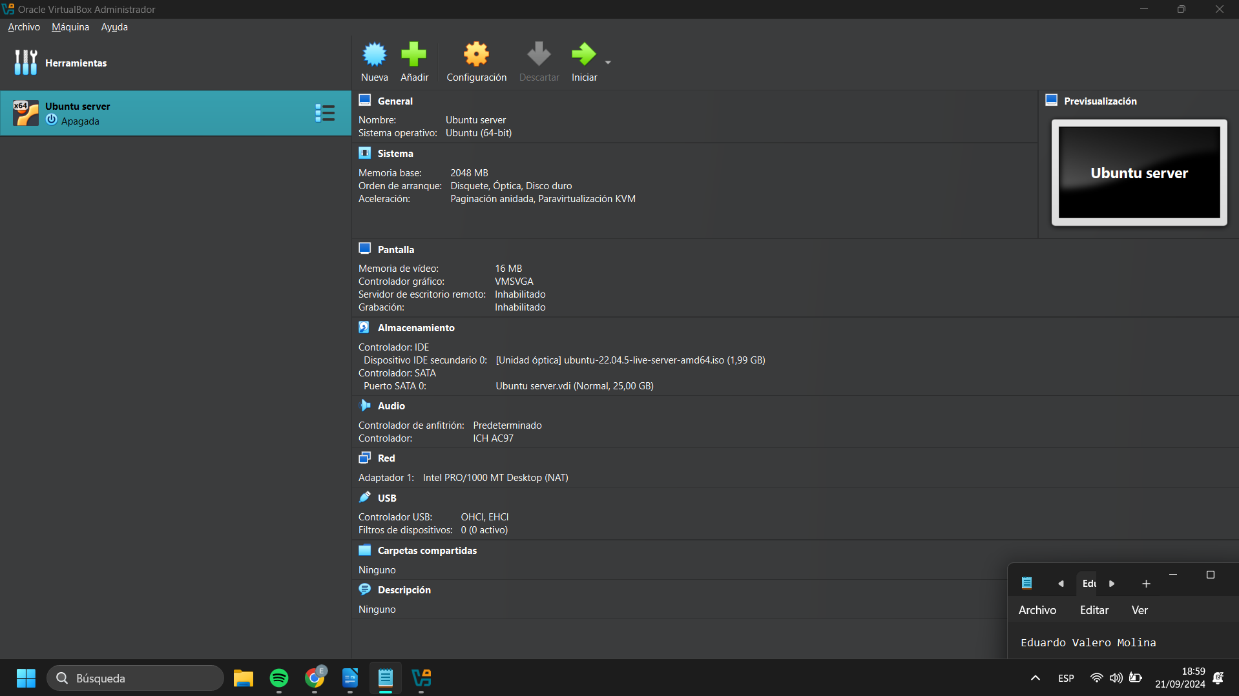Figure 2 : Machine created
In the settings, we access the general section, and in the boot methods, we select the first one to start with the previously selected ISO. We can also set the amount of RAM we want. .

In the system section, we can define the video memory we want, and it is recommended to set it to 32 MB.
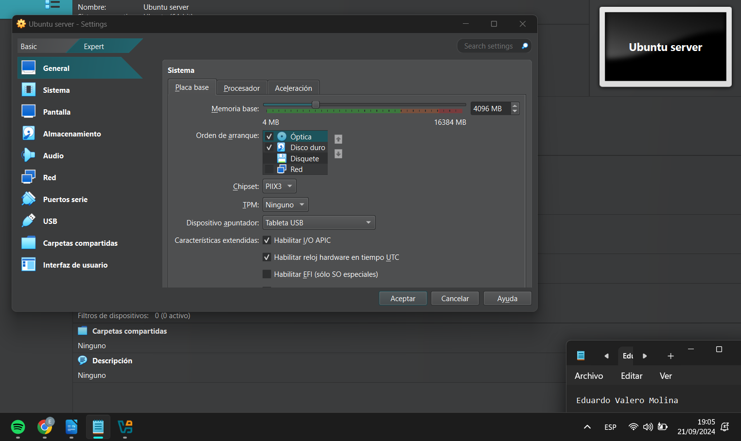Figure 4 : Choosing the boot option and amount of RAM.
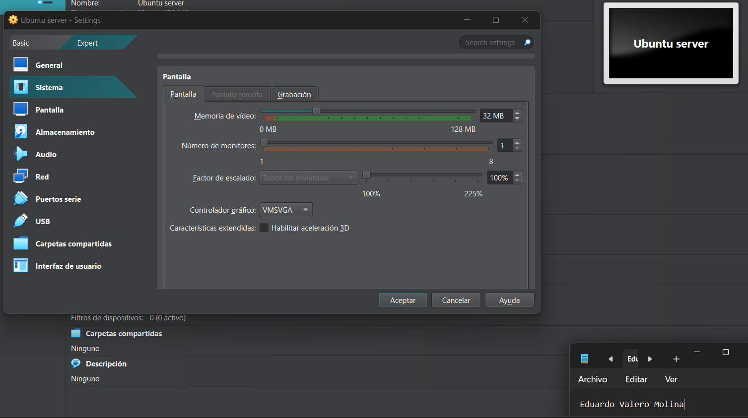Figure 5 Asignated memory of video
In the following images, we are at the installation part of Ubuntu Server, where we need to choose the type of keyboard depending on our location.
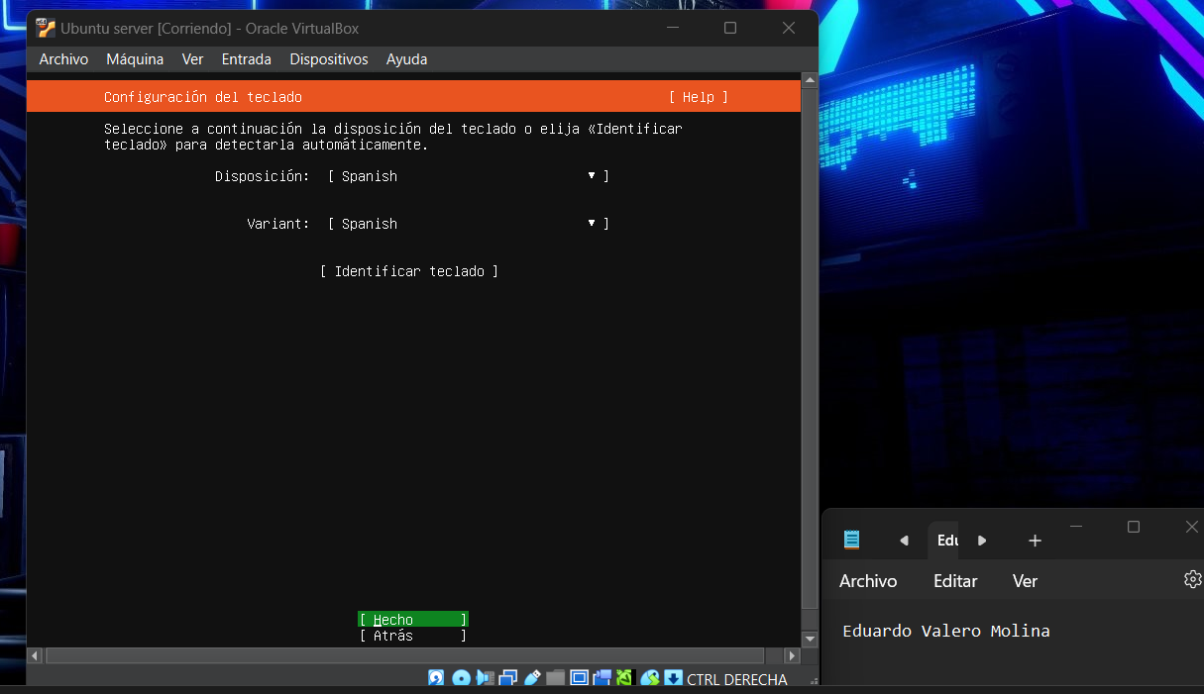Select the word hecho and push enter.
Figure 7 : installation ubuntu server
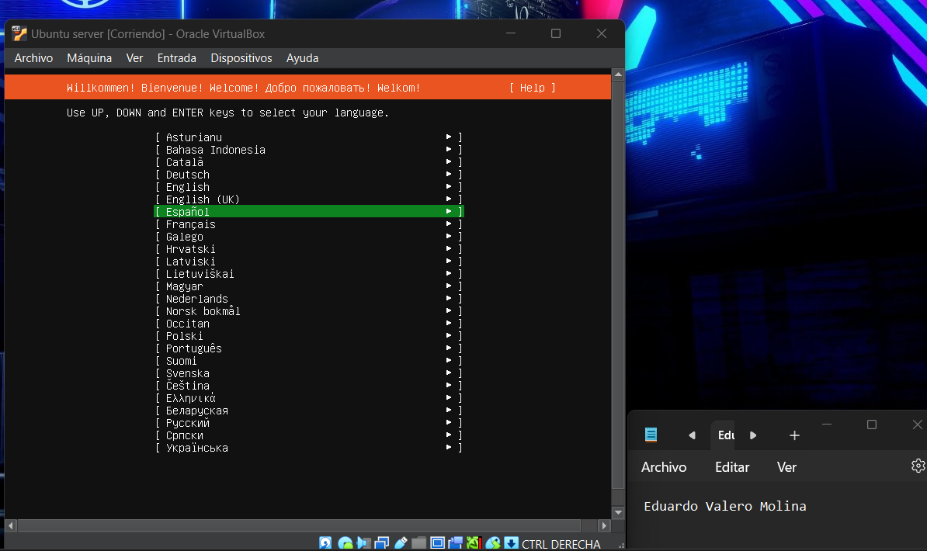Figure 6 : Installation ubuntu server
In images 8, 9, 10, 11, 12, 14, and 15, we just need to select the word "fact" or "next" and hit enter.
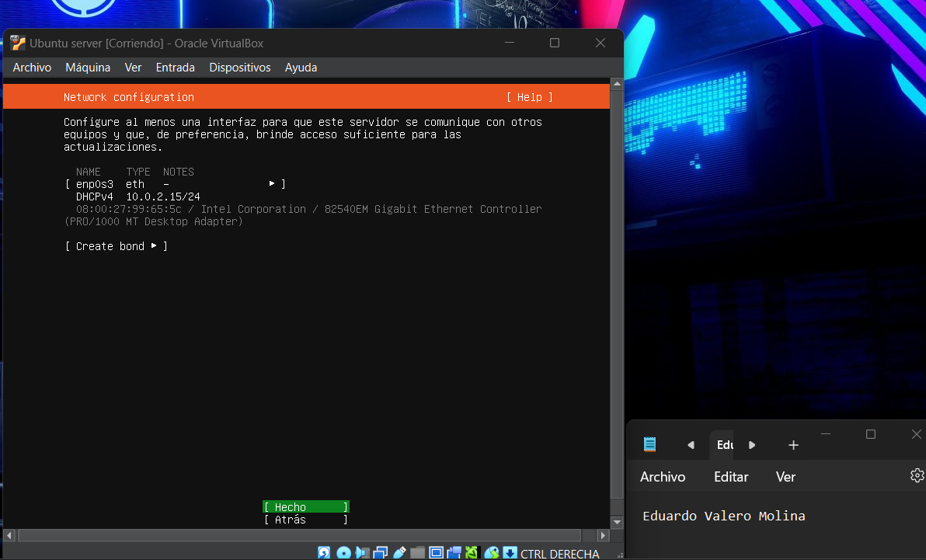Figure 9 installation ubuntu server
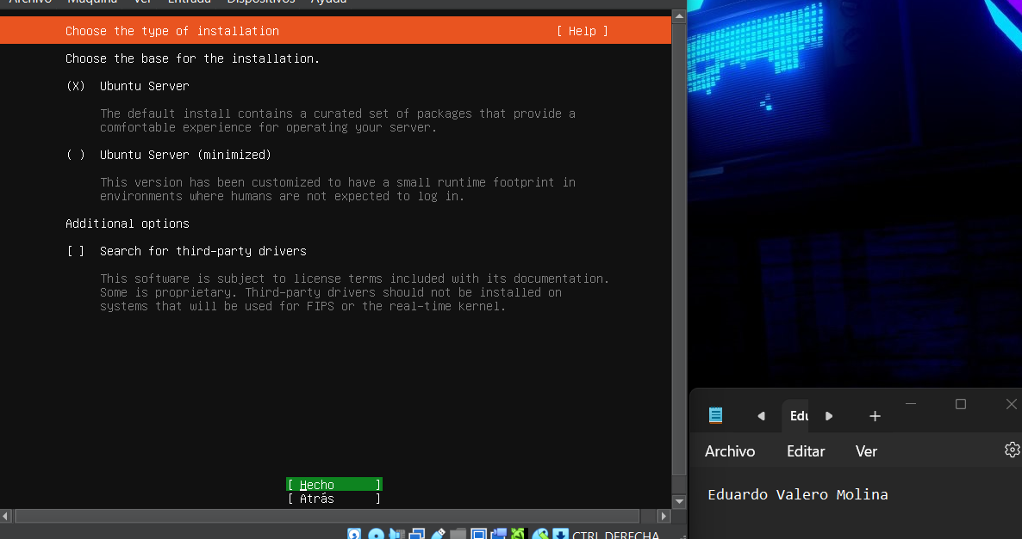Figure 8 installation ubuntu server
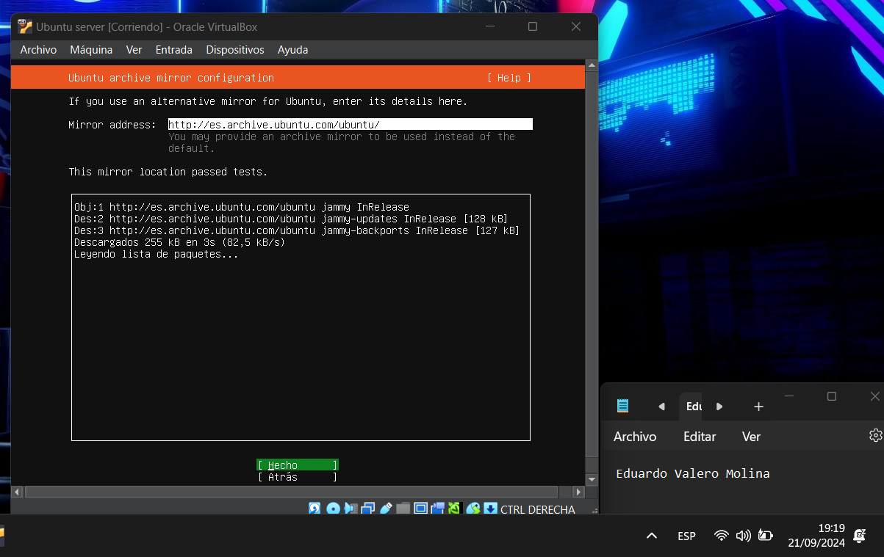Figure 10 installation ubuntu server
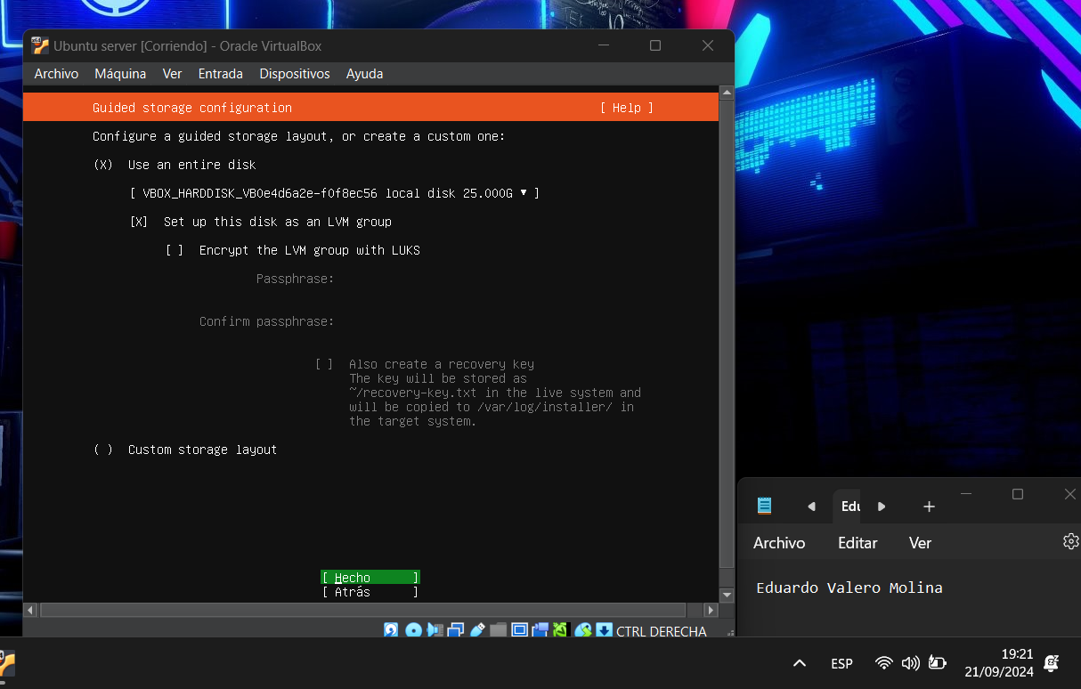Figure 11 installation ubuntu server
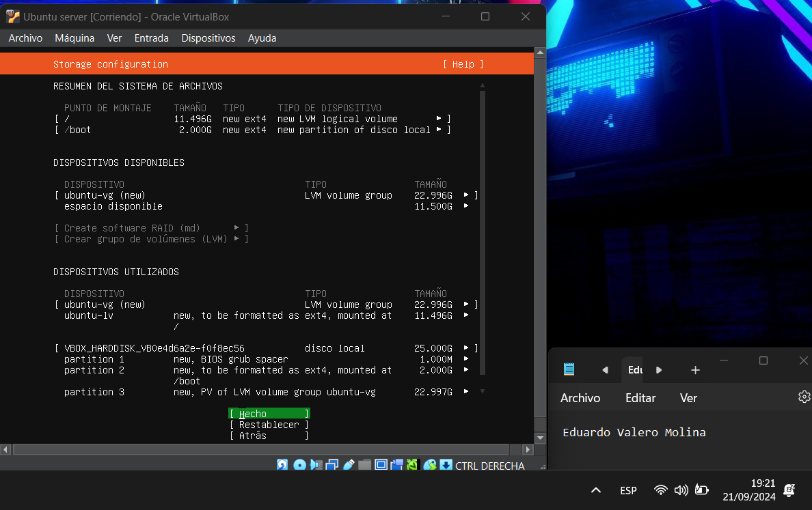Figure 12 installation ubuntu server
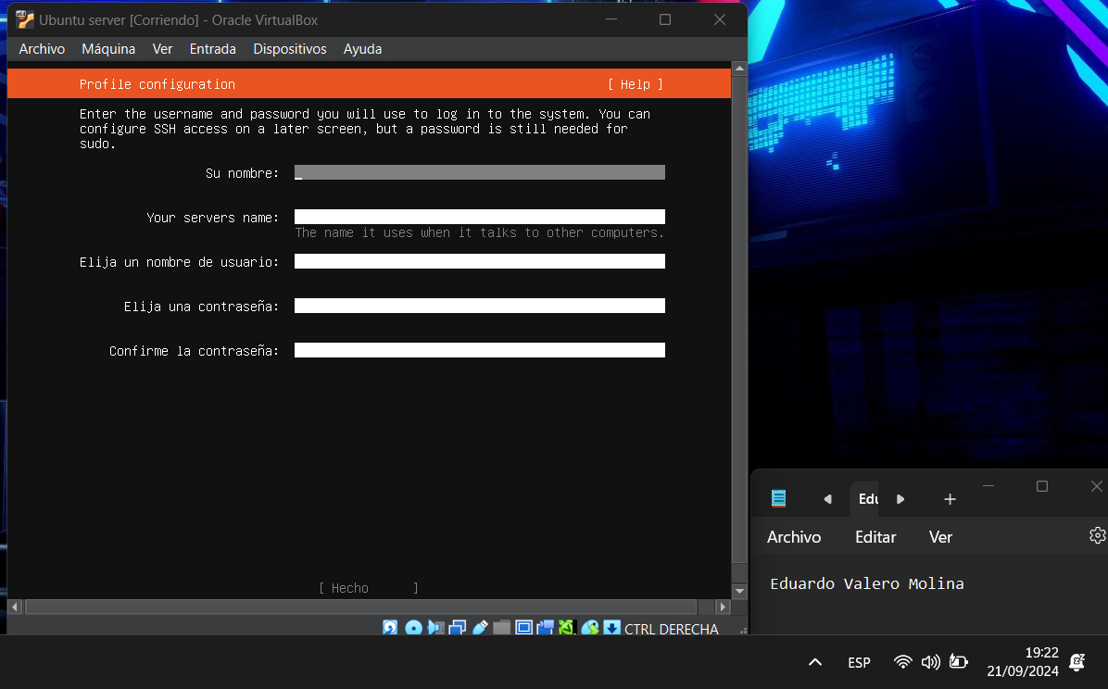In this section, you only need to enter the server name, the username, the computer name, and the password (IT IS IMPORTANT TO WRITE DOWN THE PASSWORD).
Figure 13 installation ubuntu server
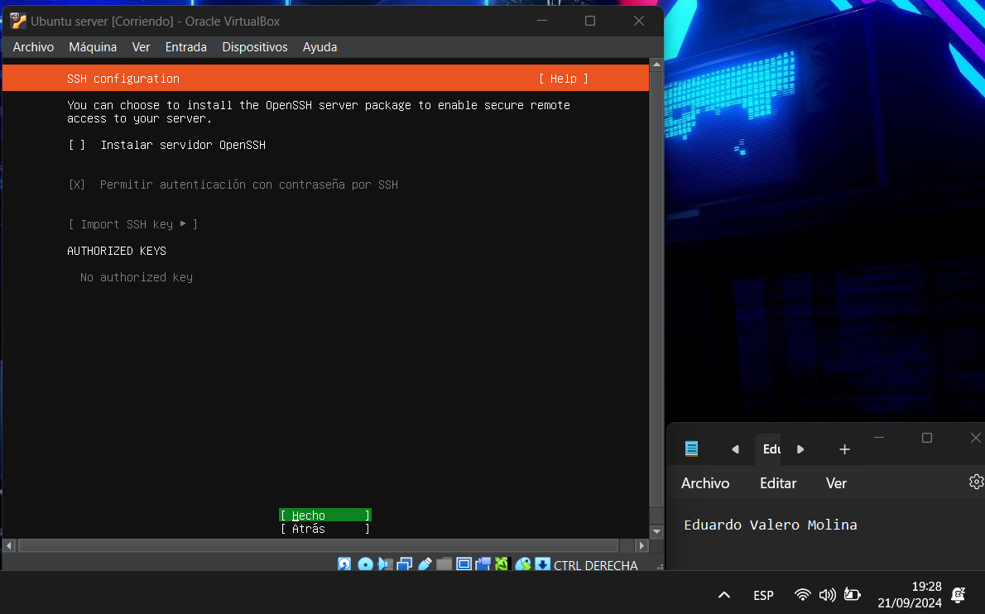Figura 14 installation ubuntu server
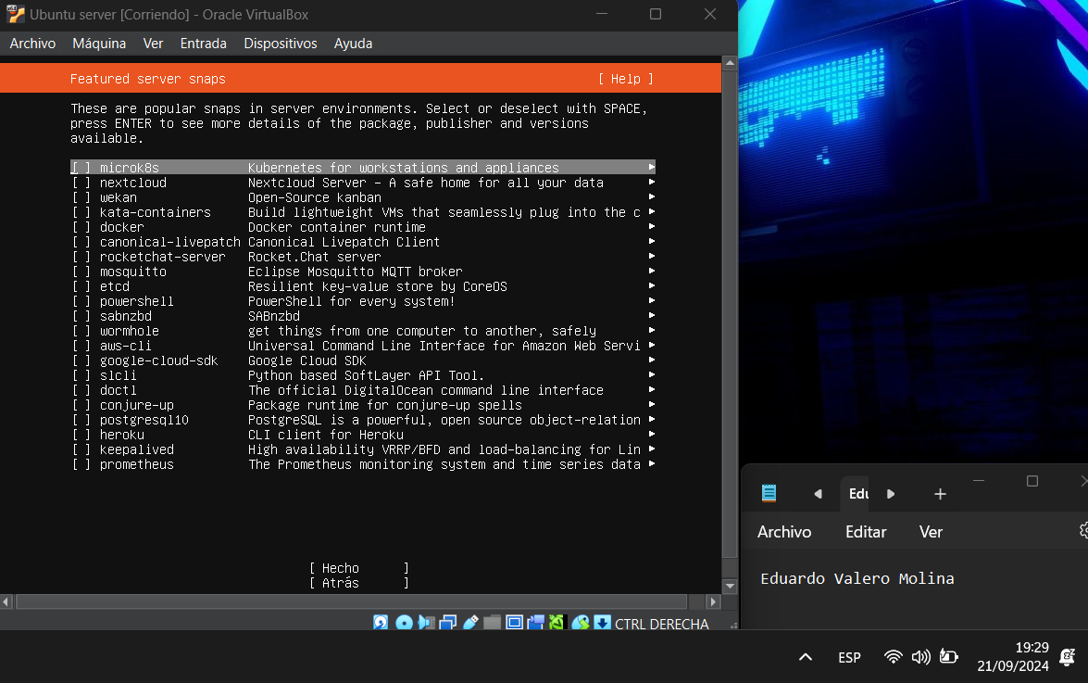Figura 15 installation ubuntu server
Once installed, it will give us the option to restart, and that is what we will do; we will click on restart and press enter.
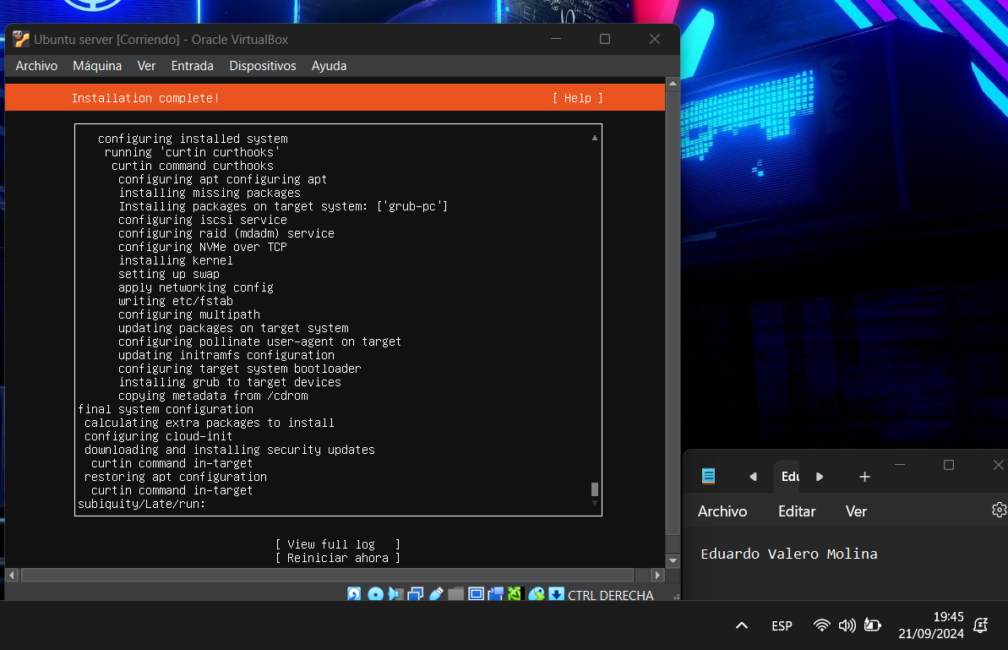Figure 16 finish the installation of ubuntu server
After Ubuntu Server has rebooted, we will install the graphical environment as seen in the accompanying image. We'll use the following command to update the files in the first image: apt-get update sudo.
Figure 17 Ubuntu commands

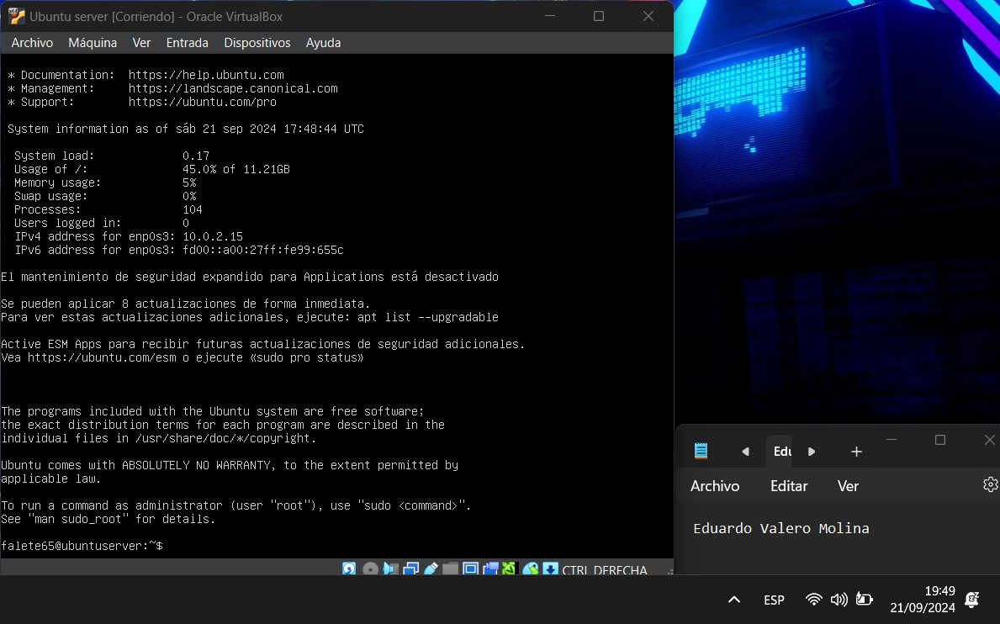After Ubuntu Server has rebooted, we will install the graphical environment as seen in the accompanying image. We'll use the following command to update the files in the first image: apt-get update sudo.
And in the next image, we will enter the last command, which is sudo apt-get --reinstall install ubuntu-desktop, and the installation of the graphical mode will proceed
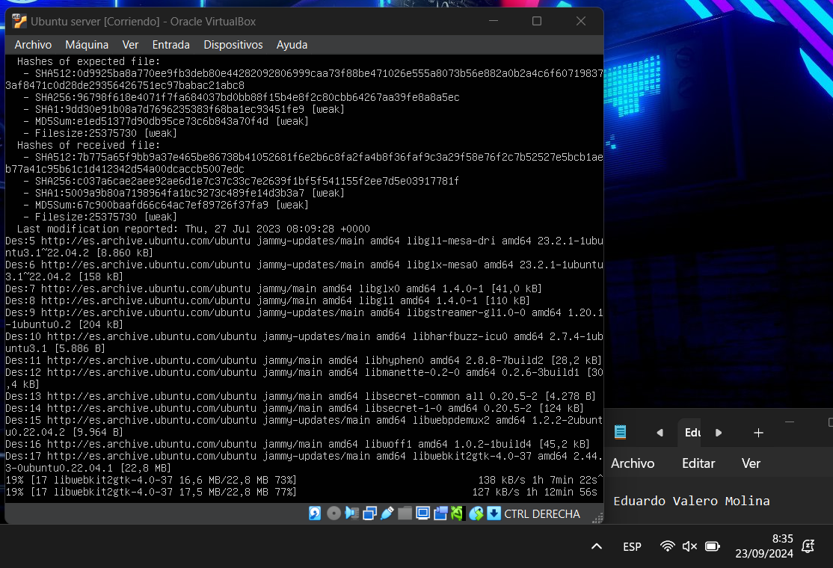Figure 18 install graphical mode ubuntu desktop
After the installation process, we need to restart the machine, and if we have followed the steps correctly, the next screen will appear.
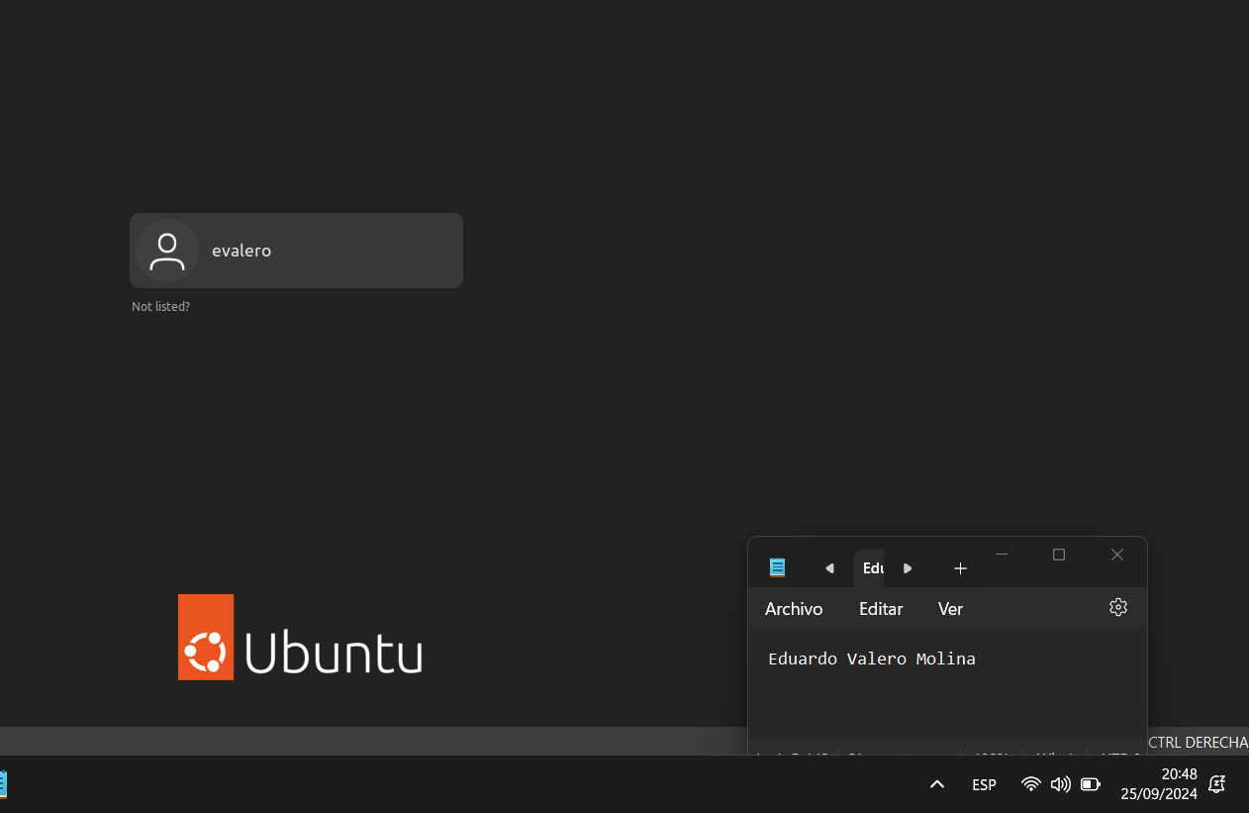Figure 20 result of the installation

5.- BIBLIOGRAFIA

https://www.virtualbox.org/wiki/Downloads

https://ubuntu.com/download/server

